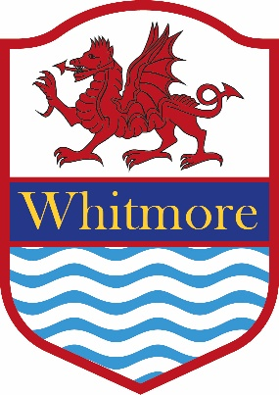
Whitmore High School

School Uniform Policy

Mandatory Requirement to wear School Clothing
By agreement with the governing body of the school, rules require all pupils to wear the approved school clothes. The governors consider that uniform promotes positive attitudes, high standards and a suitable image in the eyes of the community. It is for these reasons that our uniform requirements are enforced vigorously.

Years Seven to Eleven
Mandatory range of everyday wear for girls and boys
SKIRT  TROUSERS  TAILORED SHORTS | Plain black, no shorter than knee length, tailored school skirt  OR  Plain black, classic cut, tailored school trousers  Plain Black, Tailored | Not patterned or mottled.  Not jeans, cords, jogging bottoms, leather, flared, flecked, striped or patterned, nor any other variation of black.  Wearing of shorts is weather dependant in the Summer term, at the Head’s discretion. Students will be informed when shorts are permitted and they should not be worn outside of this time. No sports, casual or otherwise branded shorts.
SHIRT | Plain white shirt with collar | No other alternative is acceptable
TIE | School tie | No alternative or lack of tie is acceptable
BLAZER | Compulsory black blazer with embroidered school logo | No alternative is acceptable.
V-NECKED SWEATER | Optional to wear over shirt. Royal blue with embroidered school logo. | Optional
SOCKS, STOCKINGS OR TIGHTS | Plain black | No alternative is acceptable.
SHOES | Plain black, low heeled, school shoes | No other colour is acceptable.  Sandals, boots, trainers, high tops, suede, open backed shoes or open toed shoes are not acceptable.  High heels must not be worn  Should a pupil need to wear a soft shoe for medical reasons a parental/doctor’s letter is required

Uniform is available locally from the following suppliers:
A Class Apart  9 The Parade  Castle Drive  Dinas Powys  CF64 4NR  02920 515722  www.aclassapart.co.uk | Ruckleys  45 Holton Road  Barry  CF63 4HB  01446 700006  www.ruckleys.co.uk

Jewellery
For reasons of safety and security in school, the wearing of bracelets, neck chains, earrings and rings is not permitted. Ear-studs are strongly discouraged for the same practical reasons, but in any case not more than one small plain stud in each ear lobe. No piercings in any other areas are permissible e.g. facial, tongue etc. One watch. No other jewellery permitted.

Make up

Only discreet, not noticeable foundation is allowed. Any other makeup or nail varnish is not permitted.

Hair
No excessively or extreme short shaved haircuts will be allowed e.g. tram lines, shaved heads or mohicans etc. along with any unusual/unnatural dye/colouring e.g. pink, red, green etc. Other excessive or extreme hairstyles are not permitted. Hats, coloured bows and head-bands are not allowed.
Should there be any doubt about the acceptability of a particular item of wear, or of hairstyle or length, the Head’s decision must be accepted.

Clothing for Physical Education / Games / Dance
T-SHIRT | Short sleeve t-shirt, royal blue with embroidered school logo
LONG SLEEVE SPORT TOP | Long sleeve spot top, reversible, school colours with embroidered school logo
JOGGING BOTTOMS  or  SHORTS  or  SKORT  or  LEGGINGS | Plain black jogging bottoms no stripes  Plain black shorts  Plain black skorts  Plain black leggings  Black, plain  Black, plain  Black, plain
SPORT SOCKS | Black
FOOTWEAR | Rugby/Soccer boots
SPORTS TRAINERS | With non-marking soles

Suppliers
School uniform is available locally from the following suppliers:
A Class Apart  9 The Parade  Castle Drive  Dinas Powys  CF64 4NR  02920 515722  www.aclassapart.co.uk | Ruckleys  45 Holton Road  Barry  CF63 4HB  01446 700006  www.ruckleys.co.uk

